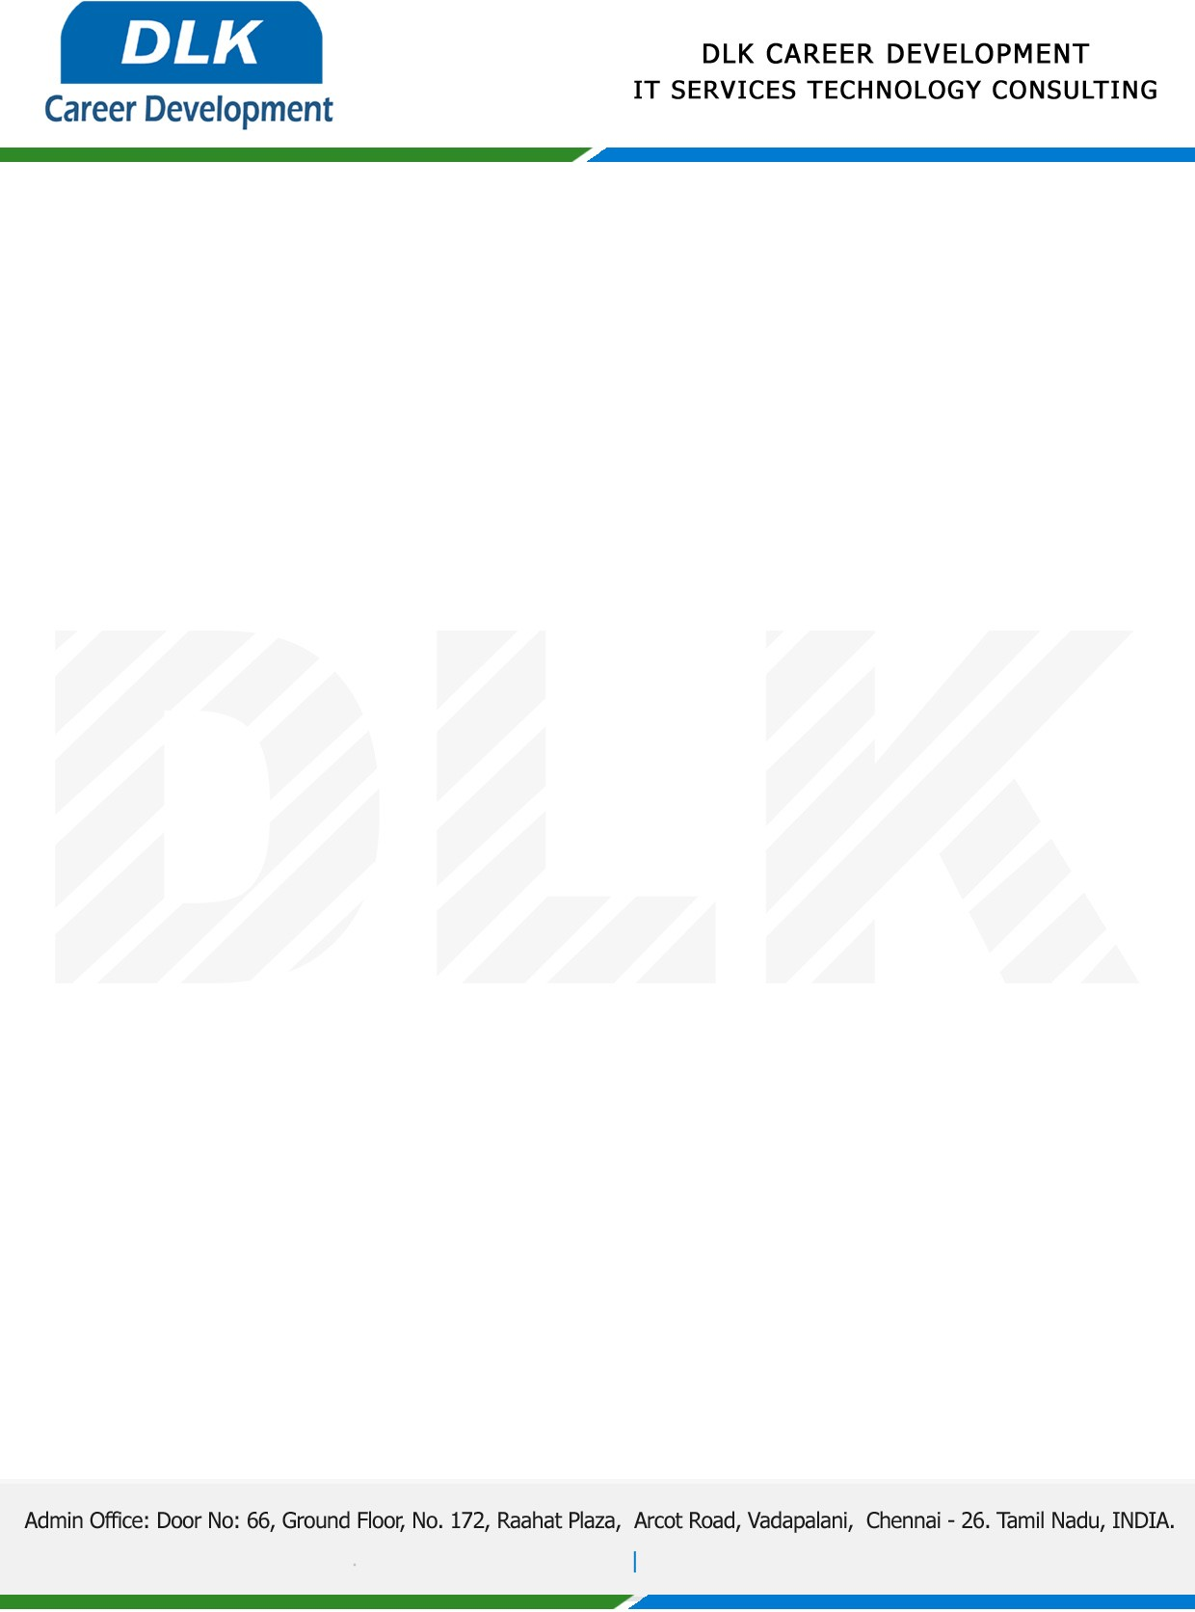

**Date: 16 February 2023**

**COURSE COMPLETION CERTIFICATE**

**Name:** MR MOHAMED ABDUL BASITH M

**Reference Number:** 3198 2483 6716

**College Name:** [K.L.N College of Engineering, Madurai.](https://stjosephs.ac.in/)

**Batch ID:** 2020 – 2022

**Program language:** Python Technology

*{Basic of Python, Machine learning,* *Deep learning, Django Framework and SQL}*

**Duration:** December 2022and February 2023 **(3 Months)**

**MR MOHAMED ABDUL BASITH M,** displayed professional traits during the Course period and managed to complete all assigned tasks as required. He was Hardworking, dedicated and committed it was a pleasure with us in this short period.

**We** **Wish all the best for your future.**

For **DLK CAREER DEVELOPMENT**

**HR Manager**

**VELMURUGAN J**